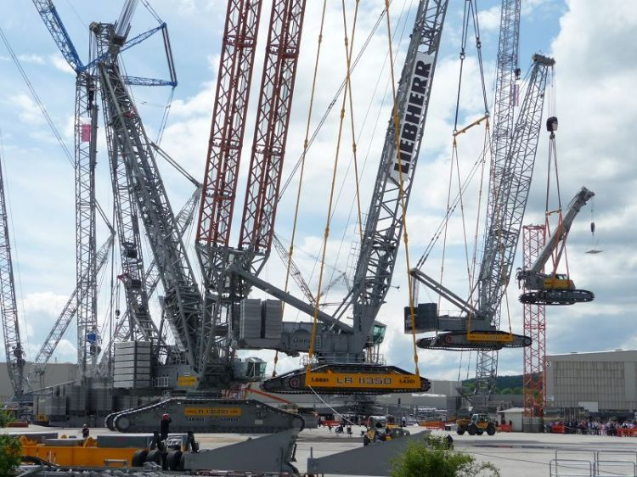

Add some **word** art for something *different*

Change picture with your own relative to assignment.

Title of the assignment

By

Student name

Student number

Title of the subject

Subject code

Submission date

Wednesday, 20 May 2015

The date field is called a dater and is also active, just click and a date picker control box will appear

# Contents

Contents iii

Table of Figures iv

1 Introduction 5

This should be on a page of its own 5

2 Methodology 2

3 Heading 1 – This text is linked to the table of contents 3

3.1 Mind map – This is an example image to be removed from assignment work. 3

4 This is a heading one – This appears on the table of contents 4

5 Heading 1 – will appear on the table of contents 4

5.1 Heading 2 – Will appear on the table of contents 4

5.2 Heading 2 – Will appear on the table of contents 5

5.2.1 Heading three – Will appear on the table of contents. 5

6 Change page layout from Portrait to Landscape 7

7 Conclusion 11

8 The Bibliography 12

9 Bibliography 15

10 Team Minutes 17

11 Index 18

12 File name: 19

13 Cover sheet: 19

14 Report format: 19

15 Presentation: 19

16 Content 20

17 Document Register 20

18 Rate your performance in the assessment task 21

18.1 Self-assessments: 21

19 Skills rubric 21

# Table of Figures

Figure 1 Formatting 2

Figure 2 Mind map of the report writing process 4

Figure 3 Captions 5

Figure 4 Missing headers and footers 6

Figure 5 Original map no highlighting 9

Figure 6 How to add a Bibliography 12

Figure 7 Click Manage sources to add an entry 12

Figure 8 Add new entry into Create Source 12

Figure 9 Adding Citations, enter Author in the Bibliography first then click Insert Citation 13

Figure 10 The Bibliography in this document has examples for you to use as a guide 15

You may use a table of figures by utilizing the tool within word. This is optional but a great way to clearly track your images and provide a quick reference for your tutor, who is your audience, to assess how well you have structured your report and in sequence as required by the unit of study..

# Introduction

Here you copy the assignment aim and purpose as you briefly introduce the subject matter you are about to study.

For example, the purpose of this assignment is to study the OHS laws of Victoria, describing how they apply to the building and construction industry. Etc. etc.

# This should be on a page of its own

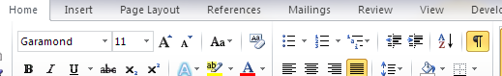

Click on the **pilcrow** symbol ¶, also called the paragraph mark, to Show/Hide all formatting marks spacing’s, paragraphs and special features such as page breaks and section breaks.

Page breaks and section breaks allow you to restart numbering, change number format, and change the page orientation from portrait to landscape. When inserting tables or pictures adding a section break will hold the object in the desired place and also hold the formatting in place.

I have deliberately left some mistakes in this document for you to find the page numbering on this page is wrong and should be Garamond 10 and should be 1 2 3 (1) not I ii iii (vi)

To fix this click on the pilcrow to find any section breaks BACK SPACE the pervious page until the section break appears on PAGE v

# Methodology

It is sometimes good to describe how you are going to write the report and this can be shown with a flow diagram. Just some circles or squares that show the steps that you are going to take. There are various software programs that can do this for you and give an extremely professional look, alternatively using shapes or smart art within word can provide a similar result.

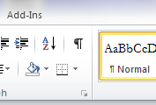

Figure 1 Formatting

When you click on this symbol it shows all the spaces in-between words as a dot and this symbol indicates the spaces in-between lines and the end of paragraphs. You also click on this symbol to show page breaks and section breaks, you need to be able to see where this formatting is if you want to delete it. Use this document as your template and delete what you don’t want and replace it.

# Heading 1 – This text is linked to the table of contents

Normal text is not linked to the table of contents.

## Mind map – This is an example image to be removed from assignment work.

This image shows you how an assignment is to be approached when you begin writing reports.

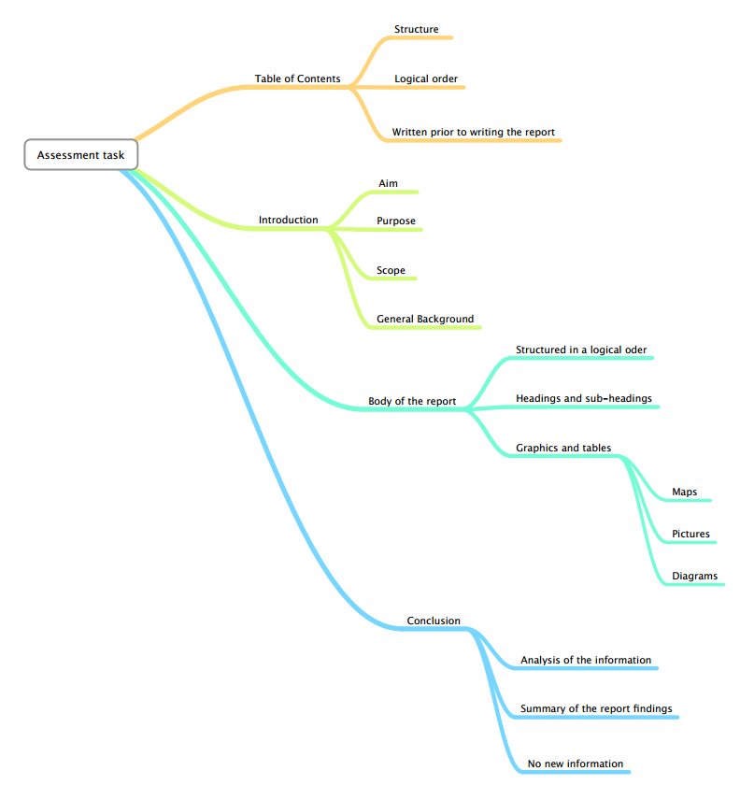

Figure 2 Mind map of the report writing process

# This is a heading one – This appears on the table of contents

Normal text

# Heading 1 – will appear on the table of contents

Normal text

## Heading 2 – Will appear on the table of contents

Normal text

## Heading 2 – Will appear on the table of contents

Normal Text

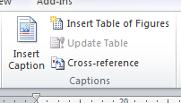 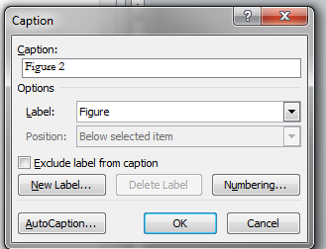

Figure 3 Captions

Click on insert caption and this drop box appears

Fill in this field click OK and you have created the caption.

### Heading three – Will appear on the table of contents.

Normal text

By default, Word displays the white space, but you can easily hide it without realizing what you've done. Hover the mouse over the top or bottom edge of any page until Word displays the white space arrows. Then, double-click the edge and Word will hide the header (and footer) and the white space. If you want to permanently remove the white space, do the following:

1. Click the File tab and choose Options (under Help) in the left pane. In Word 2003, choose Options from the Tools menu.
2. Select Display in the left pane. In Word 2003, click the Display tab.
3. Uncheck the Show White Space Between Pages in Page Layout View option.
4. Click OK

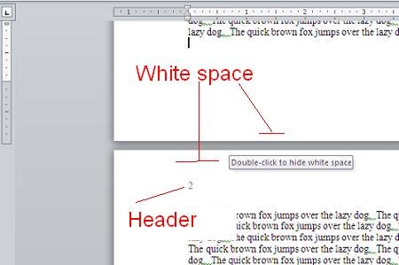

Figure 4 Missing headers and footers

# Change page layout from Portrait to Landscape



Click on the **pilcrow** symbol ¶, also called the paragraph mark, to Show/Hide all formatting marks spacing’s, paragraphs and special features such as page breaks and section breaks.

Page breaks and section breaks allow you to restart numbering, change number format, and change the page orientation from portrait to landscape. When inserting tables or pictures adding a section break will hold the object in the desired place and also hold the formatting in place.

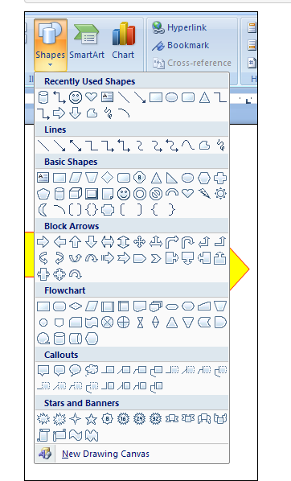

Click this symbol to create a path around an object on a map for instance. As shown below in red out line.

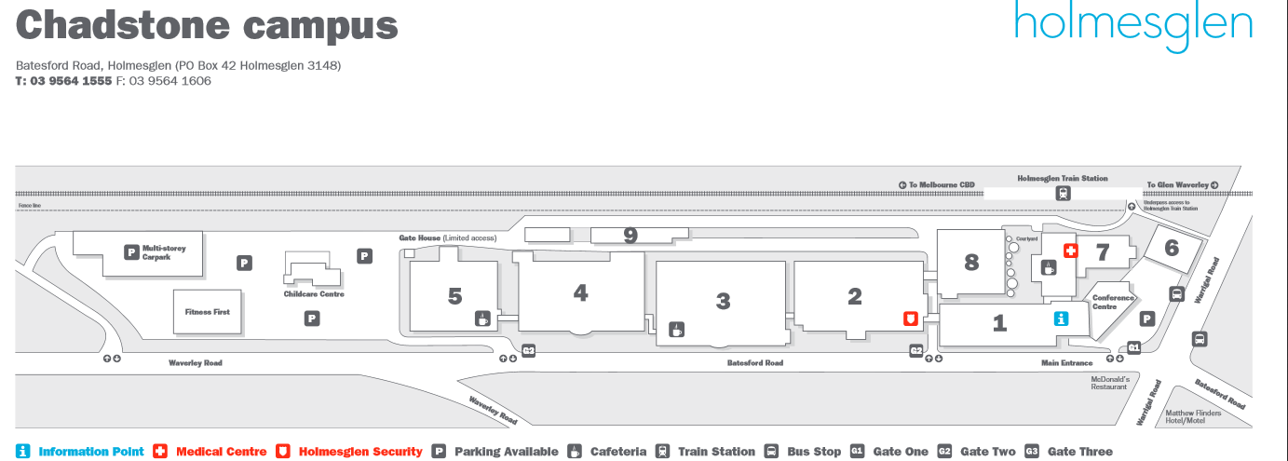

Figure Original map no highlighting

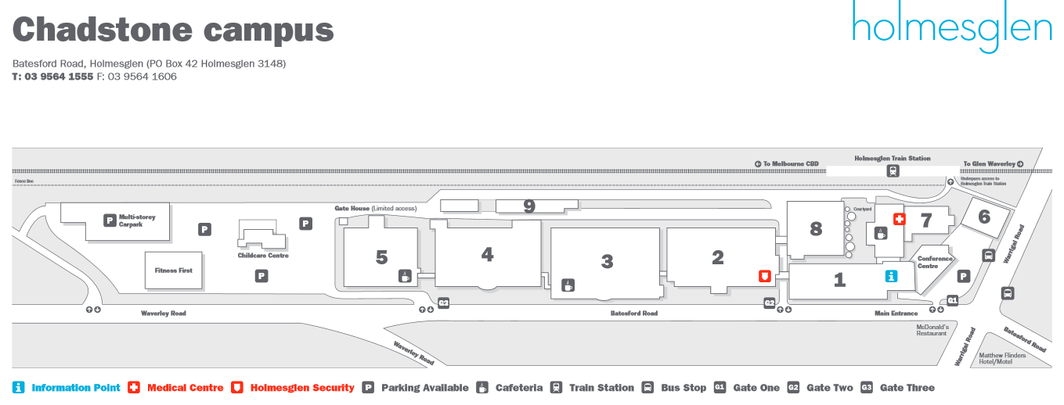

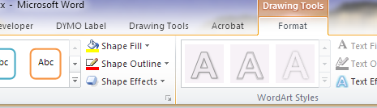

Click on shape outline to change the colour and thickness of the outline.

Click on shape fill to change the colour and in this case the transparency of the fill colour

# Conclusion

It is important to provide a summary of your findings of the report. Here you should always review the introduction, which reflects the assignment aim and purpose. This will in turn be where you answer the questions asked in the assignment aim and explain your findings and how you came to your conclusions.

# The Bibliography

This is active

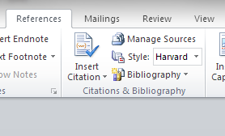

Figure 6 How to add a Bibliography

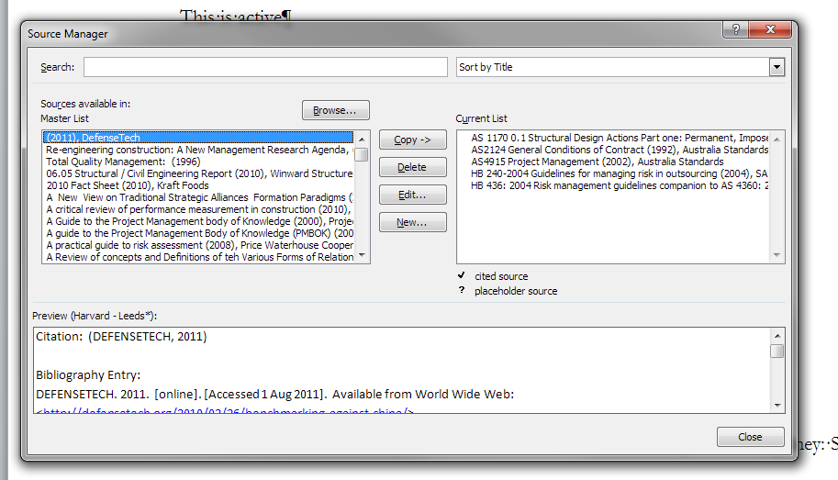

Figure 7 Click Manage sources to add an entry

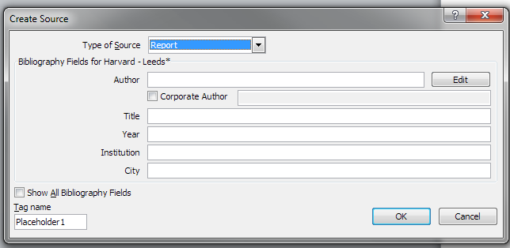

Figure Add new entry into Create Source

Note a Corporate Author is a Government or professional body, company, club or society, and includes international organisations.

Bibliography

*Using acronyms:* It is usual practice to specify the full name of an organisation the first time it is used, followed by its abbreviated name in brackets. After this, it is acceptable to use the acronym only.

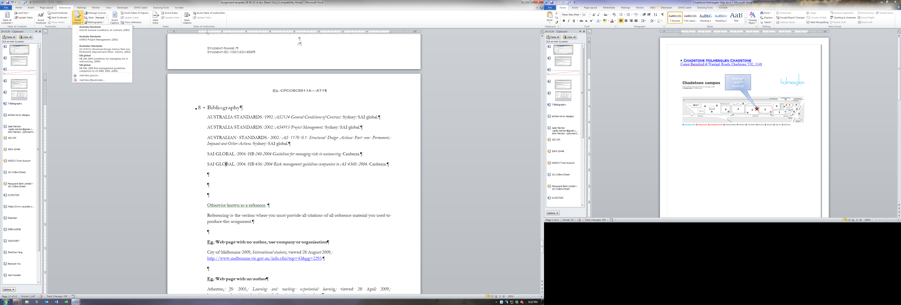

Figure 9 Adding Citations, enter Author in the Bibliography first then click Insert Citation

# Bibliography

AUSTRALIA STANDARDS. 1992. *AS2124 General Conditions of Contract*. Sydney: SAI global.

AUSTRALIA STANDARDS. 2002. *AS4915 Project Management*. Sydney: SAI global.

AUSTRALIAN STANDARDS. 2002. *AS 1170 0.1 Structural Design Actions Part one: Permanent, Imposed and Other Actions*. Sydney: SAI global.

SAI GLOBAL. 2004. *HB 240-2004 Guidelines for managing risk in outsourcing*. Canberra.

SAI GLOBAL. 2004. *HB 436: 2004 Risk management guidelines companion to AS 4360: 2004*. Canberra.

Figure 10 The Bibliography in this document has examples for you to use as a guide

Otherwise known as a reference.

Referencing is the section where you must provide all citations of all reference material you used to produce this assignment.

**E.g. Web page with no author, use company or organisation**

City of Melbourne 2009, International students, viewed 28 August 2009, <http://www.melbourne.vic.gov.au/info.cfm?top=43&pg=2293>.

**E.g. Web page with an author**

Atherton, JS 2005, Learning and teaching: experiential learning, viewed 28 April 2009, <http://www.learningandteaching.info/learning/experience.htm>.

**E.g. Australian Standards**

Standards Australia 1999, Residential timber-framed construction. Part 4, simplified- non-cyclonic areas, AS 1684.4-1999, Standards Australia International, Strathfield, NSW.

**E.g. Legislation and Government Regulations**

Occupational Health and Safety Act 2004, (VIC).

Please refer to the Holmesglen website – learning commons – referencing section for more on how to reference.

How to use referencing tool in word – refer to following link freely available on the internet.

<https://www.youtube.com/watch?v=MKco-0ye3yg>

# Team Minutes

# Index

Bibliography vi

Citations vi

Conclusion 8

Contents v

**cover sheet** iii

**Cover Sheet** iii

date field ii

date picker control box ii

format page numbers v

Header 7

Table of Figuresdent Self-Assessment Checklist

Student Self-Assessment Checklist

# File name:

yymmdd CPCCBC5003A Student name Assessment Task 1

# Cover sheet:

3 copies,

1. Hard copy Signed and dated handed to the teacher on the due date.
2. Soft copy PDF Signed and dated uploaded onto Brightspace.
3. Soft copy in the assignment signed and dated uploaded onto Brightspace.

# Report format:

1. Work to be presented in a report format as set out in the template provided.
2. Pdf format of the report is also to be uploaded.

# Presentation:

Title Page,

Course code and title,

Name and student number,

Due date,

Submission date,

Cover sheet Signed and dated,

Table of contents,

Introduction /conclusion,

Headers footers and page numbering,

Bibliography in the Harvard format,

Spelling and grammar,

Formatting, consistent spacing’s and consistent font’s,

# Content

List content topics covered (Table of contents) address the assessment task criteria.

Content length displays depth of learning adequately.

Information is gathered from a variety of sources.

Content is written in the students’ own words.

More than one reference source used.

All sources are referenced using the Harvard style bibliography.

# Document Register

|  |  |  |  |  |  |
| --- | --- | --- | --- | --- | --- |
| File Name: | Uploaded By: | Date of Upload: | Due Date: | Checked By: | Assessed Quality of the Document: |
|  |  |  |  |  |  |
|  |  |  |  |  |  |
|  |  |  |  |  |  |
|  |  |  |  |  |  |
|  |  |  |  |  |  |

# Rate your performance in the assessment task

## Self-assessments:

1. Stupendous
2. Excellent
3. Very good
4. Good
5. Dreadful
6. Abysmal

# Skills rubric

|  |  |  |  |  |
| --- | --- | --- | --- | --- |
| **Grades max is 100%** | **Skills** | **Comment** | **Understanding** | **Knowledge** |
| **HD 80 - 100** | **Sophisticated** | Transferability | Deep | Very high |
| **D 70 - 79** | **Advanced** | Contingencies, independent | Thorough | Substantial |
| **C 60 - 69** | **Creditable** | Problem solving, some independence | Creditable | Reasonable |
| **P 50 - 59** | **Satisfactory** | Competent | Basic | Sufficient |
| **N 0 - 49** | **Underdeveloped** | Not yet competent | Gaps | Insufficient |